Sanity test with an open source test automation tool.

To run the test in your system, the needed setup is

1. JDK 1.8 or above

<https://www.oracle.com/java/technologies/javase/javase-jdk8-downloads.html>

1. Eclipse IDE

<https://www.eclipse.org/downloads/packages/release/neon/2/eclipse-ide-java-developers>

1. Selenium 3.14 jar files

<https://www.selenium.dev/downloads/>

1. Chromedriver (if using chrome browser for testing. If using other browsers for testing then use related browser driver)

<https://chromedriver.chromium.org/downloads>

1. Test NG (plugin in eclipse 🡪click on Help 🡪 eclipse marketplace. )

For some versions of eclipse if unable to find.

Click on Help 🡪

Install new software 🡪

Type :- <http://beust.com> in work with field and click on Add

**Steps to follow for each project**

1. Add selenium jar files by following steps
   1. Right click on the project
   2. Click on build path
   3. Configure build path
   4. Add external jars
   5. Add all the selenium jars

(Once correctly done, we would we see a referenced library in the project with all the selenium jars added)

1. Copy and paste the chromedriver.exe into the project class path.
2. Add TestNG libray to the project
   1. Right click on project folder
   2. Click on build path
   3. Add Libraries
   4. Select TestNG

Note:- If all the above steps are successfully done. Our project folder would look like this

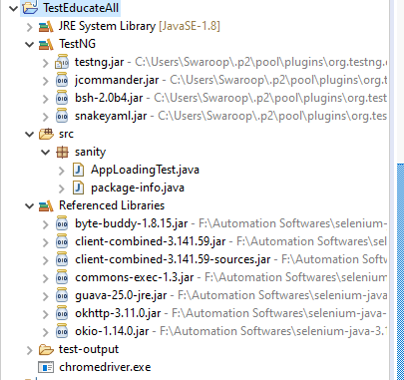

Where EducateAll is our project name , sanity is our package name and AppLoadingTest is our test name.

The following user stories have been automated and verified to be successfully running.

Test NG results on console

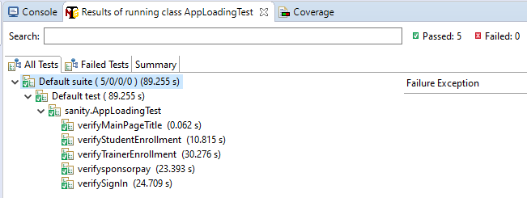

In the output folder, we can get various formats of test reports

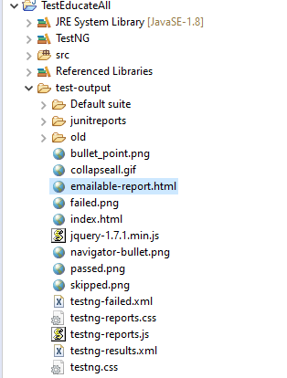

The automation test code is pasted below

package sanity;

import java.util.ArrayList;

import org.openqa.selenium.By;

import org.openqa.selenium.JavascriptExecutor;

import org.openqa.selenium.WebDriver;

import org.openqa.selenium.WebElement;

import org.openqa.selenium.chrome.ChromeDriver;

import org.testng.Assert;

import org.testng.annotations.BeforeTest;

import org.testng.annotations.Test;

public class AppLoadingTest {

WebDriver driver = new ChromeDriver(); // Initialization

@BeforeTest()

public void openBrowser() {

// 1) Open the browser // 2) Maximize it // 3) Navigate to the app

System.setProperty("webdriver.chrome.driver", "chromedriver.exe");

driver.manage().window().maximize();

driver.get("https://mini-project--deborahbs.repl.co/");

}

// 4) Verify Title

@Test(priority = 0)

public void verifyMainPageTitle() {

String expectedTitle = "Teach the Poor";

String actualTitle = driver.getTitle();

Assert.assertEquals(actualTitle, expectedTitle);

}

@Test(priority = 1)

public void verifyStudentEnrollment() throws InterruptedException {

driver.findElement(By.xpath("//a[@href='#get-involved']")).click();

driver.findElement(By.partialLinkText("Enroll")).click();

ArrayList<String> tabs = new ArrayList<String>(driver.getWindowHandles());

driver.switchTo().window(tabs.get(1));

String expectedTitle = "Student Enrollment Form | Teach the Poor";

String actualTitle = driver.getTitle();

Assert.assertEquals(actualTitle, expectedTitle);

driver.findElement(By.id("inputfname")).sendKeys("Debora");

driver.findElement(By.id("inputlname")).sendKeys("Baddipudi");

driver.findElement(By.id("inputEmail4")).sendKeys("Mailtodeborah1@gmail.com");

driver.findElement(By.id("inputPassword4")).sendKeys("hello123");

JavascriptExecutor js = (JavascriptExecutor) driver;

WebElement subbutton = driver.findElement(By.xpath("/html/body/div/div/div/div[2]/form/button"));

js.executeScript("arguments[0].scrollIntoView(true);", subbutton);

subbutton.click();

String expectedTitle1 = "Successfull Enrollment Form | Teach the Poor";

String actualTitle1 = driver.getTitle();

Assert.assertEquals(actualTitle1, expectedTitle1);

driver.quit();

}

@Test(priority = 2)

public void verifyTrainerEnrollment() throws InterruptedException {

WebDriver driver = new ChromeDriver();

driver.manage().window().maximize();

driver.get("https://mini-project--deborahbs.repl.co/");

Thread.sleep(3000);

driver.findElement(By.xpath("//a[@href='#get-involved']")).click();

driver.findElement(By.partialLinkText("Join")).click();

ArrayList<String> tabs = new ArrayList<String>(driver.getWindowHandles());

driver.switchTo().window(tabs.get(1));

String expectedTitle = "Trainer Enrollment Form | Teach the Poor";

String actualTitle = driver.getTitle();

Assert.assertEquals(actualTitle, expectedTitle);

driver.findElement(By.id("inputfname")).sendKeys("Debora");

driver.findElement(By.id("inputlname")).sendKeys("Baddipudi");

driver.findElement(By.id("inputEmail4")).sendKeys("Mailtodeborah1@gmail.com");

driver.findElement(By.id("inputPassword4")).sendKeys("hello123");

JavascriptExecutor js = (JavascriptExecutor) driver;

WebElement subbutton = driver.findElement(By.xpath("/html/body/div/div/div/div[2]/form/button"));

js.executeScript("arguments[0].scrollIntoView(true);", subbutton);

subbutton.click();

String expectedTitle1 = "Successfull Enrollment Form | Teach the Poor";

String actualTitle1 = driver.getTitle();

Assert.assertEquals(actualTitle1, expectedTitle1);

driver.quit();

Thread.sleep(5000);

}

@Test(priority = 3)

public void verifysponsorpay() throws InterruptedException {

WebDriver driver = new ChromeDriver();

driver.manage().window().maximize();

driver.get("https://mini-project--deborahbs.repl.co/");

Thread.sleep(3000);

driver.findElement(By.xpath("//a[@href='#get-involved']")).click();

driver.findElement(By.partialLinkText("Give")).click();

ArrayList<String> tabs = new ArrayList<String>(driver.getWindowHandles());

driver.switchTo().window(tabs.get(1));

String expectedTitle = "Sponsor Donation Form";

String actualTitle = driver.getTitle();

Assert.assertEquals(actualTitle, expectedTitle);

driver.close();

Thread.sleep(5000);

}

@Test(priority = 4)

public void verifySignIn() throws InterruptedException {

WebDriver driver = new ChromeDriver();

driver.manage().window().maximize();

driver.get("https://mini-project--deborahbs.repl.co/");

Thread.sleep(3000);

driver.findElement(By.xpath("//*[@id=\"dropdown01\"]")).click();

driver.findElement(By.xpath("//a[@href='sign-in.html']")).click();

ArrayList<String> tabs = new ArrayList<String>(driver.getWindowHandles());

driver.switchTo().window(tabs.get(1));

String expectedTitle = "Sign-In | Teach the Poor";

String actualTitle = driver.getTitle();

Assert.assertEquals(actualTitle, expectedTitle);

driver.close();

Thread.sleep(5000);

}

}